NOTICE OF LOGIC AND ACCURACY TEST OF VOTING EQUIPMENT, EARLY VOTING & ELECTION DAY VOTING LOCATION FOR 2024 PRIMARY ELECTION

Public notice is hereby given that a Logic & Accuracy Test of Voting Equipment will be conducted in accordance with the provisions of Section 20A-4-104(1)(b). Registered voters in Sanpete County can vote early for the June 25th, 2024 Regular Primary Election in accordance with the provisions of Section 20A-3a-604(1), Utah Code Annotated. Drop box locations are noticed in accordance with the provisions of Section 20A-5-403.5. Details specified below:
Logic & Accuracy Test of Voting Equipment
Sanpete County Clerk's Office 160 N Main, Room #202, Manti, Utah May 29th, 2024 at 11:00 a.m.

Early Voting
Sanpete County Clerk's Office 160 N Main, Room #202, Manti, Utah. Monday June 17th – Thursday June 20th &
Monday June 24th, 2024 8:30 AM - 5:30 PM

Election Day: June 25th, 2024 7:00 am- 8:00 pm
Drop-Box Locations: A list of the locations is on the county website at sanpete.com/elections.html

Questions: (435) 835-2131 ext. 5 elections@sanpetecountyutah.gov

Voters can view sample ballots and learn more about this election on the state's election website at vote.utah.gov.
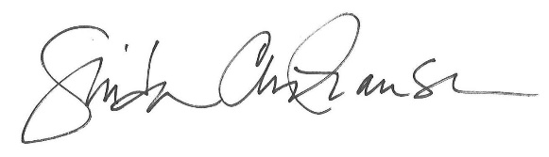

Linda Christiansen
Sanpete County Clerk

