Sanpete County Drop-off Locations
Come drop off your voted ballots at one of the following locations:
24 Hour drop-off locations
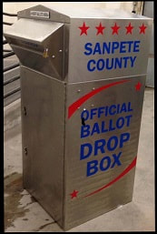
Sanpete County Courthouse Ephraim City Hall
160 North Main, Manti 5 South Main, Ephraim
(Driveway South of Courthouse) (East of Building)
Mt. Pleasant City Admin Office Gunnison City Hall
106 West Main, Mt. Pleasant 38 W Center, Gunnison
(Drive Thru) (East of Building)

These Other City Buildings Will Now Have a Ballot Drop Box in Their City Buildings
Please call your City office for offices operating hours.

Centerfield City Hall Mayfield Town Hall
130 South Main St. 50 South Main
M-Th 9am–5pm F 9am-2pm M-Th 9am-4pm
Fairview City Hall Moroni City Hall
85 South State St. 80 South 200 West
M-Th 8am-4pm M-Th 9:30am-2:30PM
Town of Fayette Spring City Hall
100 East Center St. 45 South 100 East
T & Th 9:30am-3pm M-Th 9am-4pm
Fountain Green Hall Wales
375 North State St. 150 North State
M-Th 9am-4pm F 9am-noon M 10am-6pm T 8am-12

Ballots can be dropped off at the County Clerk’s Office
160 north Main, Suite 202, Manti, UT
M-Th 8:00 am - 6:00 pm Fri. 8:00 am - 12:00 pm
Election Day 7:00am – 8:00 pm
*NEW*
Track your ballot!
Sign up today at ballottrax.utah.gov/voter/

