Sanpete County Drop-off Locations
Come drop off your voted ballots at one of the following locations:
24 Hour drop-off locations

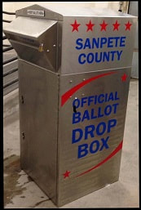
Sanpete County Courthouse Ephraim City Hall
160 North Main, Manti 5 South Main, Ephraim
(Driveway South of Courthouse) (East of Building)

Mt. Pleasant City Admin Office Gunnison City Hall
106 West Main, Mt. Pleasant 38 W Center, Gunnison
(Drive Thru) (East of Building)

These Other City Buildings Will Now Have a Ballot Drop Box in Their City Buildings
Please call your City office for offices operating hours.

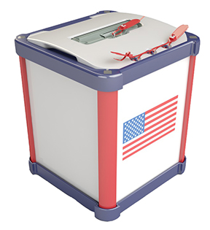
Centerfield City Hall Mayfield Town Hall
130 South Main St. 50 South Main
(435) 528-3296 (435) 528-5061

Fairview City Hall Moroni City Hall
85 South State St. 80 South 200 West
(435) 427-3858 (435) 436-8395

Town of Fayette
100 East Center St.
(435) 528-5882

